Patient’s Personal History & Health Assessment

Date: _________
Patient Name: _________________________________ D.O.B._________ Gender: ______
Weight _______ Height _________ Race:_________ Language:______________
Soc. Sec. #: _____________________________
Patient Street Address: ____________________________ City: ______________________
State:____ Zip Code: __________ Home Phone:______________ Cell Phone: ___________
Communication Preference: _____Email ______ US Mail _____Home phone
_____Cell phone _____ Work Patient Portal

Employer: __________________________ Employer Phone: _______________________ Nearest Relative/kin: __________________________ Relationship: __________________
Address: ____________________________ City: ______________________State:______
Zip Code: __________ Home Phone:_____________ Cell Phone: ____________________
Date of Last Physical Exam: _____________________ Physician ____________________

Pharmacy Name: ___________________________ Address: ________________________ City: ________________ State:______ Zip Code: __________ Phone:_________________
Fax: ____________________

Medical Equipment: (Please mark all that applies to you)
Do you use a Cane ______ Oxygen _______ Walker _______ Wheelchair _______ Nebulizer _____
Do you own or rent this equipment? ____________

Do you use Glasses? ____ Yes ____ No Date of last eye Exam? _______
Hearing Aid _____

Social History:
Alcohol _____ Smoking ______ Drugs ______ Other _______
Religion: ____________________

Marital Status:
____ Married ____ Widowed ____Single ____ Divorced ____ Separated ______Live Alone

Immunizations:
___ Pneumococcal ____ Rubella ____ Tetanus ___ Influenza ____ Diptheria ___Other

Family History:
 | Alive | Dead | Age | Cause of Death
Mother

Father

Brother

Sister

Living Arrangements Yes No
Do you own your home ____ ____
Do you rent your home? ____ ____
Do you live alone? ____ ____
Do you have a will? ____ ____
Do you have a living will? ____ ____
Do you need other legal assistance? ____ ____
Do you have an Advanced Directive? ____ ____
Do you have surrogate decision letter? ____ ____

Personal Habits
Have you ever smoked tobacco? ___ Yes ___ No
Are you a regular smoker now? ___ Yes ___ No
Number of cigarettes per day ______ ____ Cigars ____ Pipe
How long have you been smoking? _______________ Number of years

Check if you regularly drink: Social/ occasional drinker
Hard liquor ____ 1-3 oz. per day ____ Over 3 oz. per day
Beer ___ 1 bottle per day ____ 2 bottles ___ 3 or more
Wine ___ 1 glass per day ____ 2 glasses 3 or more
Dou you drink coffee? ____ Yes _____ No _____3 or more cups

Do you exercise?
Regularly ___ Occasionally ____ Rarely ____

Have you used any of the following:
___ Marijuana ___LSD ____Heroin ___ Cocaine ___ Speed
____Other similar substances

Lifestyles (optional) | Yes | No
Are you sexually active?

If yes, please answer the following questions:
Sexual preference
Partner same sex | Yes | No
Partner opposite sex
Partners of both sexes
Do you consistently use contraceptives

Activities of Daily Living | Yes | No
Do you use a catheter for urine?
Do you have a problem using the toilet?
(for urination bowel movement)
Do you drive?

Occupational | Yes | No
Are you presently employed?
Does or did your work involve unusual work, exposure to dust, noise, radioactivity etc.?
Are you limited at work because of disability?
Are you retired?

Types of work you have done:
_______________________________________________________________________________________________________________________________________________________________________________________________________________________________________________________________

Social History
Have you recently lived or traveled outside the U.S.
___ Yes ___No

Do you eat less than three meals a day?
___ Yes ____ No

Do you have special food customs or restrictions?
___ Yes ____ No

Do you use any community services now?
___ Yes ____ No

Check if you have/had any of the following illnesses. If unsure, leave blank:
Condition/Illness | Self | No | Relative | Not Sure
Alcohol overuse
Allergies (other than medication)
Anemia
Arthritis
Asthma
Bleeding Tendency
Cancer
CVA/TIA
Colitis
Heart Disease (CHF, CAD,MI)
Depression/Anxiety
Diabetes
Dialysis
Emphysema/COPD/Bronchitis
Epilepsy
Frequent Kidney/Bladder infection
Frequent Lung Infections
Gallbladder Disease
Cardiac Arrhythmias/
pacemaker
Gout
Heart Attack
High Cholesterol
Hepatitis
High Blood Pressure
Intestinal Polyps
Jaundice
Leukemia
Headaches
Nervous Break Down
Radiation or Chemotherapy
Rheumatic Fever
Sexually Transmitted Disease
Sickle Cell Anemia
Stomach Ulcers
Stroke
Suicide Attempt
Thyroid
Tuberculosis
Sleep Apnea

Childhood Illness: ( Check if you have/had any of the following illnesses. If unsure, leave blank:)
Measles ______ Mumps _____ Chicken Pox _____ Hay Fever ____ Other _____

Operations/ Surgeries : List and Indicate approximate year.
________________________________________________________________________________________________________________________________________________________________________________________________________________________________________________________________________________________________________________________

Serious Injuries: (other than the above) List and Indicate approximate year.
__________________________________________________________________________________________________________________________________________________________________________________________________________________________________________

Hospitalizations: (other than operations)
________________________________________________________________________________________________________________________________________________________________________________________________________________________________________________________________________________________________________________________

Medications: Do you take the following
____Aspirin, Bufferin, Anacin, Tylenol or similar product
____ Motrin, Advil
____ Vitamins ____ Other prescription or over the counter drugs

List each drug or medication, its amount and how often you take it.
________________________________________________________________________________________________________________________________________________________________________________________________________________________________________________________________________________________________________________________________________________________________________________________________________________________________________________________________________________________________________________________________________________________________________________________________________________________________________________________________________________________________________

Are you Allergic to any medications? ___ Yes ___ No
If yes, please list the medications and the reaction you had with them:
__________________________________________________________________________________________________________________________________________________________________________________________________________________________________________

Do you have any environmental or food allergies? ____ Yes ____No
If yes, please list them and the reaction you had to them:
_______________________________________________________________________________________________________________________________________________________________________________________________________________________________________________________________
PLEASE BRING ALL YOUR MEDICATION YOU’RE TAKING TO EVERY APPOINTMENT
Please check “YES” to the following questions ONLY if the problem is of significant concern in the past (1 month) or unless the question specifically states “EVER
REVIEW of SYSTEMS:
General | YES | NO
Do you usually feel persistently tired or worn out?
Have you recently been drinking more waters or fluids?
Has there been any unusual weight gain or loss recently?

Cardiovascular | YES | NO
Do you have pain, tightness or pressure in the front or back of your chest?
Have you been told your electrocardiogram was abnormal?
Do you have swelling in your feet or ankles?
Does your heart ever beat fast or irregularly?
Do you have cramps in the calf muscles when you walk?
Do your fingers or toes ever get cold, become numb, or get very white or bluish?

Central Nervous System | YES | NO
Dou you often have spells of dizziness, faintness or lightheadedness?
Do you have frequent headaches?
Have you recently fainted, blacked out, lost consciousness?

Have you ever wanted to commit suicide?
Do you ever hear voices or see people when no one is around?
Do you have trouble remembering recent
events?
Do you ever have convulsions or fits?
Have you ever wanted to commit suicide?
Do you ever hear voices or see people when no
one is around?

Eyes | Yes | No
Do you experience pain in your eyes?
Did you have glaucoma or cataract?
Have you experienced changes in your vision?
Have you experienced halo around lights?

ENT: (Ear, Nose, Throat) | Yes | No
Do you have any trouble hearing?
Do you have ringing or buzzing in your ears?
Do you have earaches or discharge from your
ears?
Do you have drainage down the back of your
throat?
Do you have frequent or sever nosebleeds?
Do you have persistent hoarseness?

Gastrointestinal | Yes | No
Have you recently had any changes in your
eating habits?
Have you recently noted any trouble in
swallowing?
Do you have a lot of indigestion or heartburn?
Have you ever vomited blood?
Are you bothered with constipation?
Do you have frequent loose stools or diarrhea?

Skin | Yes | No
Do you have any changes in the color of your skin?
Do you have any rashes or itching?
Do you have any growths or lumps on your skin?
Do you have any sores or wounds that do not heal?
Do you have any changes in the color or size of warts or moles?

Genitourinary | Yes | No
Do you have burning or pain when you urinate?
Do you have to pass water frequently?
Do you have to get up at nights?
Do you have trouble with loosing urine when you cough or sneeze?
Have you ever passed blood in your urine?
Have you ever had an operation to prevent
pregnancy?
(Vasectomy or sterilization, such as tubal
ligation)
Have you had herpes?

Musculoskeletal | Yes | No
Do you have joint pain or stiffness (arthritis)?
Do you ever have a problem with back pain?
Does your back pain interfere with your work or activities?
Do you have trouble walking or using your hip, knee joints?

Respiratory | Yes | No
Do you have frequent chest colds or
pneumonia?
Do you have a constant or bothersome cough?
Do you have blood when you cough?
Do you have difficulties breathing?
Do you have wheezing in your chest?

Women Only | Yes | No
Did you have any pregnancies?
Total number of pregnancies?
Have you had any lumps in your breast?
Have you had any abnormal bleeding from the vagina in the past year?
Have you passed the menopause or change?
Do you have any prolapse(falling out)of the vagina or uterus?
Have you had a hysterectomy?
Do you have any vaginal drainage?
Men Only: Do you have prostate gland trouble?

PAIN ASSEESSMENT:
PAIN: YES _________ NO _________ LOCATION: __________
COMMENTS: ______________________________________________________
________________________________________________________________________________________________________________________________________________________________________________________________________________________________________________________________________
TREATMENT PLAN: ________________________________________________________________________________________________________________________________________________________________________________________________________________________________________________________________________
Please draw where the primary pain is located using the diagram below:

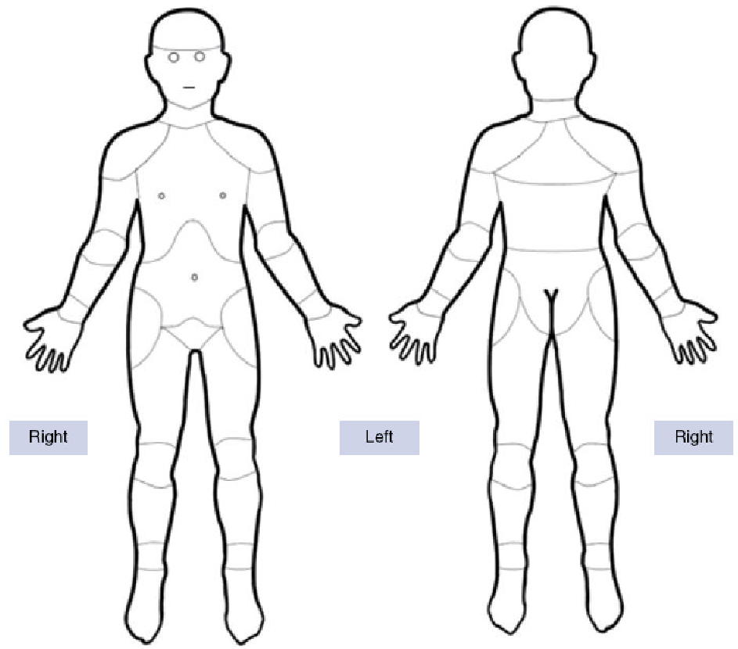

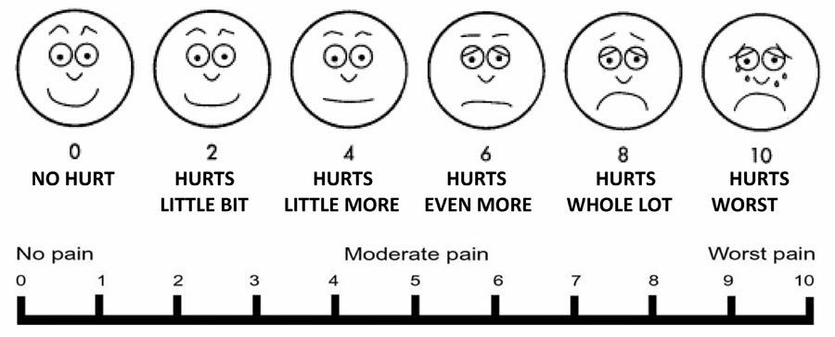

CONSENT FOR TREATMENT

I HEREBY CONSENT TO AND AUTHORIZE A PHYSICIAN / NURSE PRACTITIONER AND/OR ANY HEALTH CARE PROFESSIONAL AT YOU & I PRIMARY CARE, AESTHETICS AND WELLNESS TO PERFORM A
PHYSICIAL EXAMINATION, DIAGNOSTIC PROCEDURE(S) AND TO PRESCRIBE A THERAPEUTIC REGIMEN. I HEREBY AUTHORIZE THE PHYSIAN(S) AND/OR NURSE PRACTITIONER OF YOU & I PRIMARY CARE, AESTHETICS AND WELLNESS TO RELEASE/COLLECT INFORMATION INCLUDING DIAGNOSIS ACQUIRED IN THE COURSE OF MY EXAM TO/FROM ANY HEALTHCARE FACILITIES, PHYSICIANS, OR INSURANCE CARRIERS.

PATIENT SIGNATURE ____________________________________________
DATE: ________________________

PRIVACY PRACTICES ACKNOWLEDGEMENT
I HAVE BEEN GIVEN A COPY OF THE PRIVACY PRACTICES AND I HAVE BEEN GIVEN THE OPPORTUNITY TO REVIEW IT.

PATIENT SIGNATURE: ____________________________________
PATIENT NAME: _________________________________________
DATE: ________________
PATIENT DATE OF BIRTH: ________________________________

INSURANCE INFORMATION AND RELEASE
Patient Name: ________________________________________________
Who is Responsible for this Account: _____________________________
Date of Birth: _______ / _______/ _______ (MM/DD/YYYY)
Social Security Number: _______, ______, _________
Insurance Company: _________________________________________________
Member Id: ________________________ Group #: _______________________
Subscriber’s Name:___________________________________________________
Relationship to Patient: _______________________________________________
Is the patient covered by additional insurance? ______ Yes ______ No
Secondary Insurance: _________________________________________________
Member Id: _________________________ Group #: _______________________
Insurance Assignment and Release
I certify that I have insurance with __________________________ , and assign directly to You & I Primary Care, Aesthetics and Wellness and all insurance benefits, if any, otherwise payable to me for services rendered. I understand that I am financially responsible for all charges whether or not paid by insurance. I authorize the use of my signature on all insurance submissions.
The above named doctor / nurse practitioner may use my health care information and may disclose such information to the above-named Insurance Company (ies) and their agents for the purpose of obtaining payment for services.
MEDICARE/MEDIGAP AUTHORIZATION
I request that payment of authorized Medicare benefits and, if applicable, Medigap benefits, be made either to me or on my behalf to You & I Primary Care, Aesthetics and Wellnes, for any services furnished to me by that provider. To the extent permitted by law, I authorize any holder of medical or other information about me to the Centers for Medicare and Medicaid Services, my Medigap insurer, and their agents any information needed to determine these benefits or benefits for related services.
Signature of Patient, Guardian or Personal Representative Date

Printed Name of Patient, Guardian or Personal Representative Relationship to Patient
Assignment of Benefits Form

Financial Responsibility
All professional services rendered are charged to the patient and are due at the time of service, unless other arrangements have been made in advance with our business office. Necessary forms will be completed to file for insurance carrier payments.

Assignment of Benefits
I hereby assign all medical and surgical benefits, to include major medical benefits to which I am entitled. I hereby authorize and direct my insurance carrier(s), including Medicare, private insurance and any other auto/health/medical plan, to issue payment check(s) directly to You & I Primary Care, Aesthetics and Wellness medical services rendered to myself and/or my dependents regardless of my insurance benefits, if any. I understand that I am responsible for any amount not covered by insurance.
Authorization to Release Information
I hereby authorize You & I Primary Care, Aesthetics and Wellness to: (1) release any information necessary to insurance carriers regarding my illness and treatments; (2) process insurance claims generated in the course of examination or treatment; and (3) allow a photocopy of my signature to be used to process insurance claims for the period of lifetime. This order will remain in effect until revoked by me in writing.
I have requested medical services from You & I Primary Care, Aesthetics and Wellness on behalf of myself and/or my dependents, and understand that by making this request, I become fully financially responsible for any and all charges incurred in the course of the treatment authorized.
I further understand that fees are due and payable on the date that services are rendered and agree to pay all such charges incurred in full immediately upon presentation of the appropriate statement. A photocopy of this assignment is to be considered as valid as the original.

Patient/Responsible Party Signature Date

Witness Date

CANCELLATION AND NO SHOW POLICY
We understand that situations arise in which you must cancel your appointment. It is therefore requested that if you must cancel your appointment you provide more than 24 hours notice. This will allow another person who is waiting for an appointment to be scheduled in that appointment slot.

Office appointments which are cancelled with less than 24 hours notification may be subject to a $50.00 cancellation fee.
Patients who do not show up for their office or blood work appointment without a call to cancel will be considered as NO SHOW. Patients who No-Show Two (2) or more times in a 12 month period may be dismissed from the practice and denied any future appointments.
The Cancellation and No Show fees are the sole responsibility of the patient and must be paid in full before the patient’s next appointment.
We understand that special, unavoidable circumstances may cause you to cancel within 24 hours. Fees in this instance may be waived but only with management approval.
Our practice firmly believes that good physician and/or Nurse Practitioner /patient relationships are based upon understanding and good communication. Questions about cancellation and no show fees should be directed to the Office Manager: Leinier Rodriguez

Please sign that you have read, understand and agree to this Cancellation and No Show Policy.

Patient Name: ____________________________________ Date of Birth: __________

Signature: ______________________________________ Date:_________________
Signature of Patient or Patient’s Representative

